**Westmorland & Furness YJS Volunteer Expression of interest form**

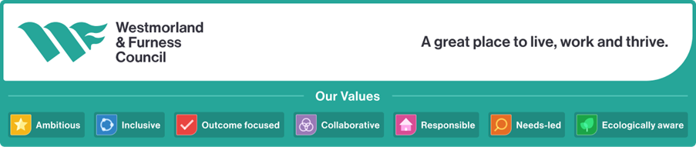

|  |  |  |  |
| --- | --- | --- | --- |
| **Your Details** | | | |
| **Title: Mr/Mrs/Miss/Ms** | **Forenames:** | | **Surname:** |
| **Full Address:**  **Postcode:** | | | |
| **Home Tel No:** | | **Daytime Tel No:** | |
| **Mobile Tel No:** | | **Email Address:** | |
| **Date of Birth:** | | | |
| **Please indicate your ethnic origin (to help ensure a balanced representation)**   |  |  | | --- | --- | | **White or White British** | **Asian or Asian British** | | **Black or Black British** |  | | **Other Ethnic origin (Please specify)** | | | | | |

**Employment Details**

**Current Employment (paid or unpaid):**

**Previous Employment:**

Thank you for your interest in volunteering. Please either complete in black ink and return to Simon Day, Westmorland & Furness YJS, Nan Tait Center, Abbey Road, Barrow-in-Furness, Cumbria, LA14 1LG marked Private & Confidential **or** complete online and email to [adam.bradley@cumbria.gov.uk](mailto:adam.bradley@cumbria.gov.uk)

**Personal Skills & Experience**

Give details of any experience you have working with children or young people (including those in your own family) or young offenders:

Please describe any skills you have that you think may be a benefit to the service, include any voluntary and paid work, general life experience, training, and education

**Area of interest**

Tell us why are you interested in becoming a volunteer?

Please write down the type of volunteering you would like to do. If you are unsure what you would like to do, just leave this blank.

Do you have a disability as defined under the 1995 Disability and Discrimination Act?

(This will not stop you from volunteering with us)

Yes/No

**Special Needs**

If you have any special needs or requirements that you feel we should know about please tell us about these here: (Diabetic, heart condition, back injury)

**Availability**

Please indicate the day(s) and approximate times you may be able to help and how often you could help us (e.g.: most Monday mornings and all day Wednesdays and some Saturdays) this is just to give us some idea when you might be available.

Are you available to volunteer for more than 12 months Yes/No

**Criminal Convictions**

Westmorland & Furness Youth Justice Service is committed to Safeguarding and promoting the welfare of children and young people and expects all volunteers to share this commitment. Due to this, rigorous checks will be undertaken of our volunteer’s background credentials including an enhanced DBS check. As part of this check you must declare if you have any unspent criminal convictions, cautions, reprimands, or warnings. A conviction will not necessarily disbar you from volunteering however, any failure to disclose such convictions could result in the ending of your volunteer role. Any information given will be treated in the strictest of confidence and will be considered only in relation to the volunteer position applied for.

*‘I declare that I am NOT currently the subject of any Police investigation and/or prosecution in the UK, or any other country. I declare that I have not been convicted of any criminal offence required by law to be disclosed, in the UK or any other country. I declare that I am not currently the subject of any investigation by anybody having regulatory functions in relation to health/social care professions, including such a regulatory body in another country.’*

|  |  |  |  |
| --- | --- | --- | --- |
| Signed: |  | Date: |  |

**If you are unable to sign this declaration, you must list all your criminal convictions, cautions, reprimands, or warnings on a separate sheet, including the date, offence, and sentence details.**

**Any other comments**

Please use this space to add any other information about your application that you feel may be of interest to us.

**Declaration:**

I hereby confirm that I wish to apply as a volunteer with Cumbria Youth Justice Service and confirm the information contained in this application is true and accurate. I further grant permission to take up such references as they feel appropriate to my application and, if required, to carry out the Police check required by law for me to work with ‘vulnerable’ people. I further give Westmorland & Furness Youth Justice Service permission to process the information provided in accordance with the Data Protection Act 1998.

|  |  |  |  |
| --- | --- | --- | --- |
| Signed: |  | Date: |  |

|  |
| --- |
| **Can you tell us where you heard about W&F YJS volunteering opportunities?** |
|  |

**Personal References**

Please provide details of two people who know you well and may be asked about your ability to act as a volunteer (one should be your most recent line manager). Your referees must not be relatives, and you must have known them for at least two years.

|  |  |  |  |
| --- | --- | --- | --- |
| Name: |  | Name: |  |
| Address: |  | Address: |  |
| Email: |  | Email: |  |
| Tel no: |  | Tel no: |  |
| Relationship  to you: |  | Relationship  to you: |  |